Linux Basic Commands

Command: whoami
      - Description: Displays the current user account.
      - Example: Running whoami in the terminal will show your username, like john_doe.

Command: ls
      - Description: Lists files and directories in the current directory.
      - Example: ls will display files and folders in your current directory, and ls -l provides detailed information.
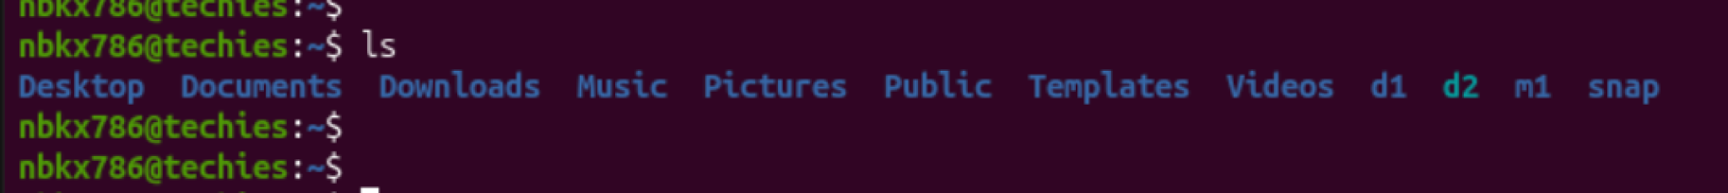
Command: ip a
      - Description: Lists your IP address and network interfaces.
      - Example: ip a show all network interfaces and their IP addresses.
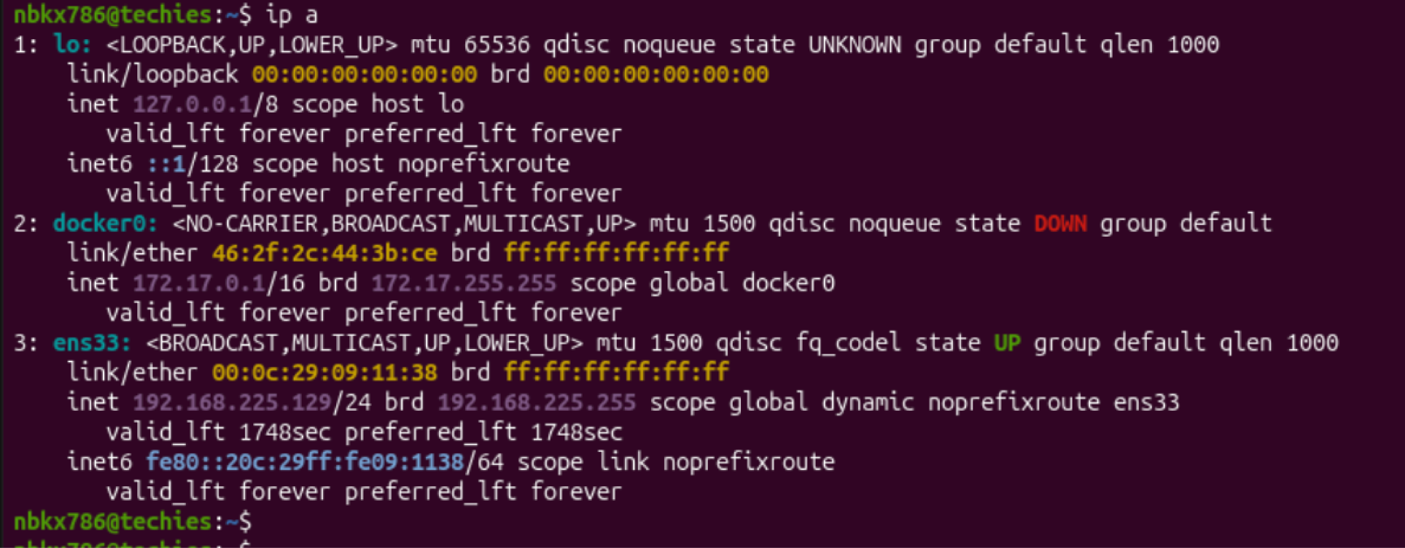
Command: cat
      - Description: Reads the contents of text files.
      - Example: cat myfile.txt will display the content of myfile.txt.


Command: passwd
      - Description: Used to change the password of the user account.
      - Example: Typing passwd and following the prompts will allow you to change your password.

Command: touch
      - Description: Creates empty files, mainly useful to test write ability.
      - Example: touch newfile.txt creates an empty file named newfile.txt.
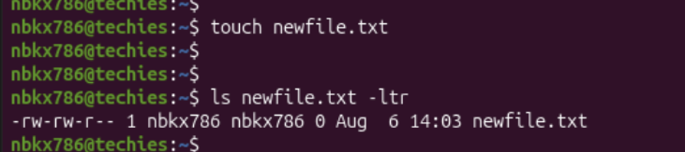
Command: pwd
      - Description: Stands for Print Working Directory; shows which directory you are in.
      - Example: Running pwd might return /home/john_doe.

Command: man
      - Description: Accesses the system documentation for commands.
      - Example: man ls will show the manual for the ls command.
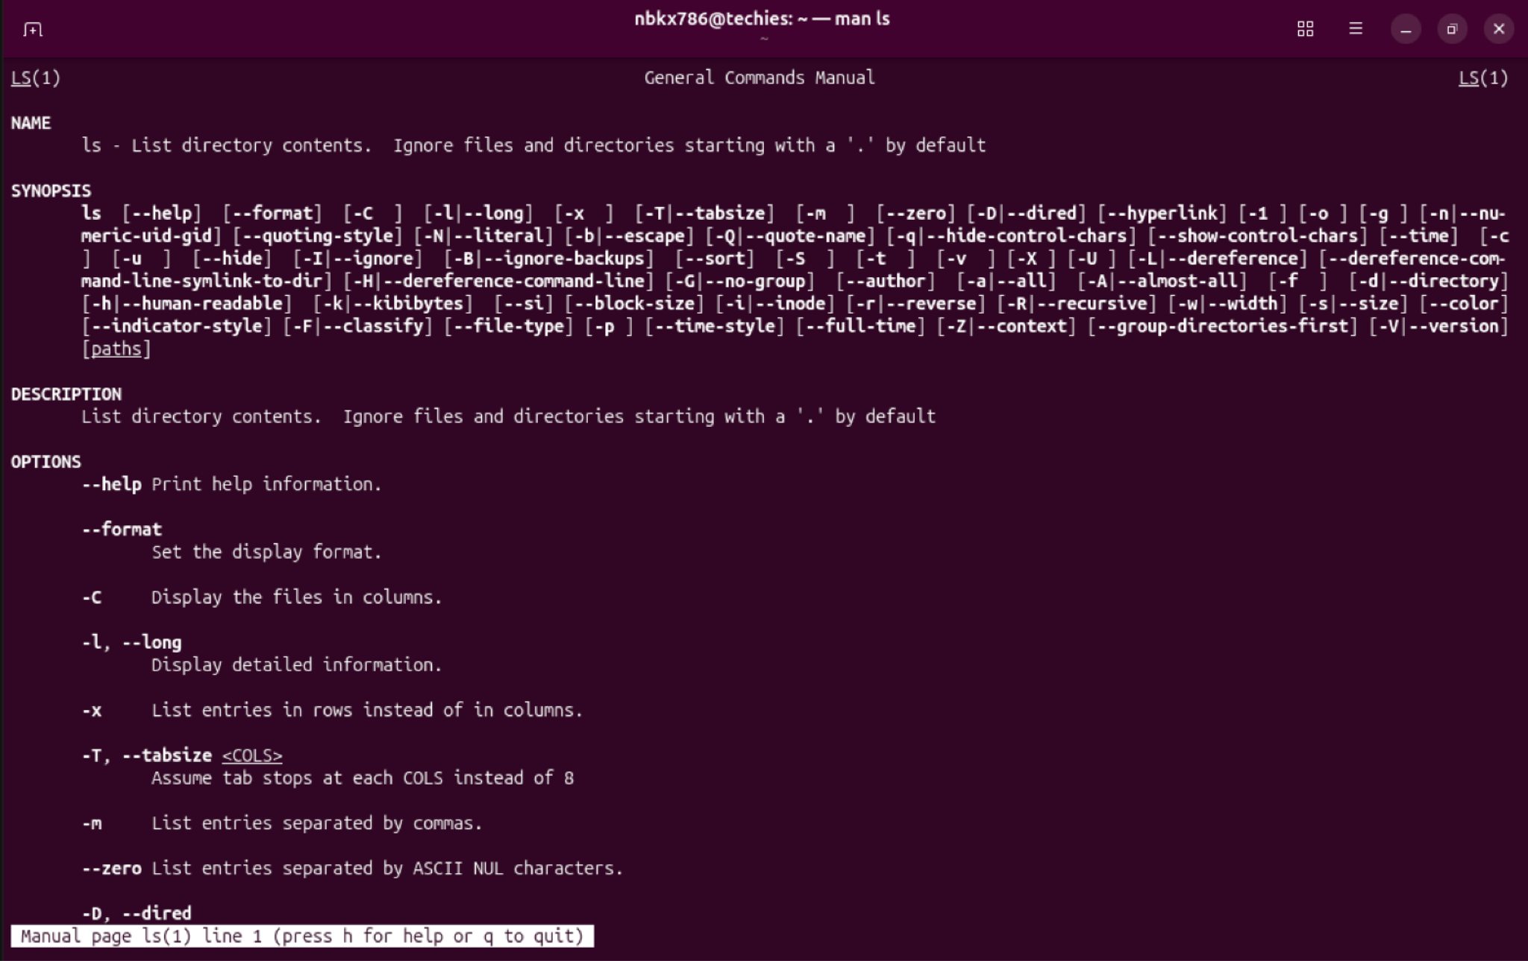
Command: apropos
      - Description: Searches commands related to a specific task based on description (equivalent to man -k).
      - Example: apropos "list files" might return commands related to listing files.

Command: pinfo
      - Description: Provides additional information, similar to man.
      - Example: pinfo ls gives detailed information about the ls command.
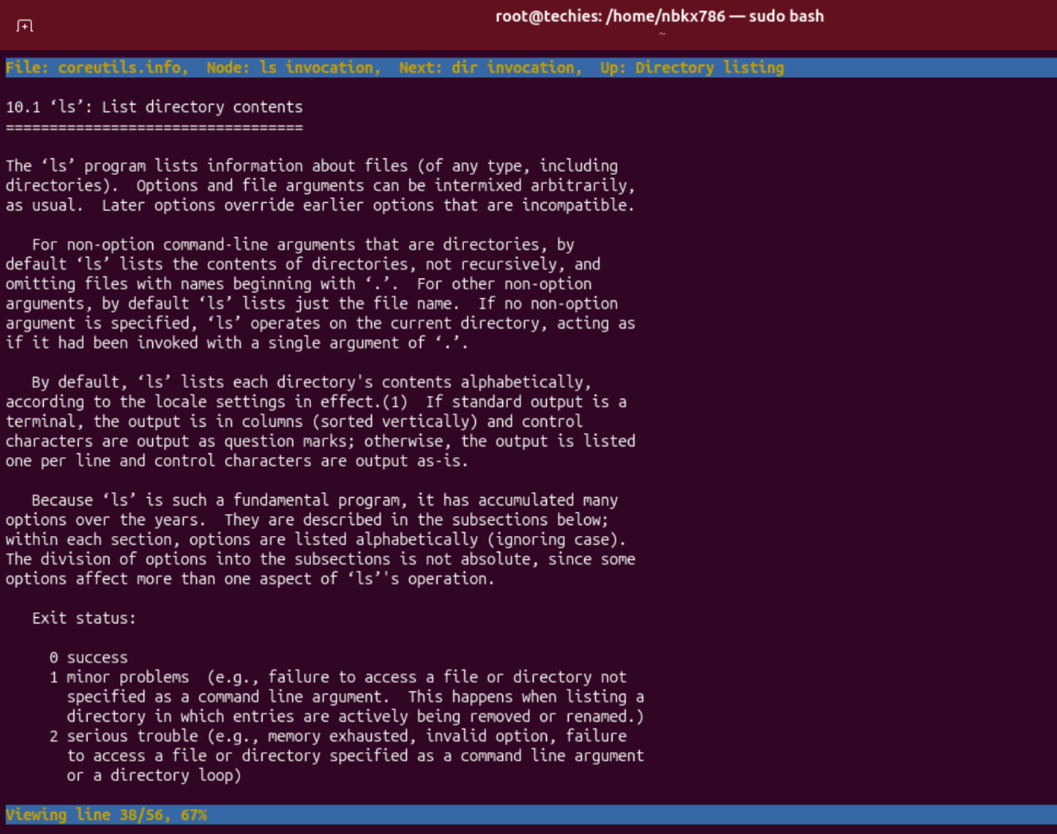
Command: tldr
      - Description: Shows command line examples, a simplified version of man.
      - Example: tldr passwd provides quick examples of how to use the passwd
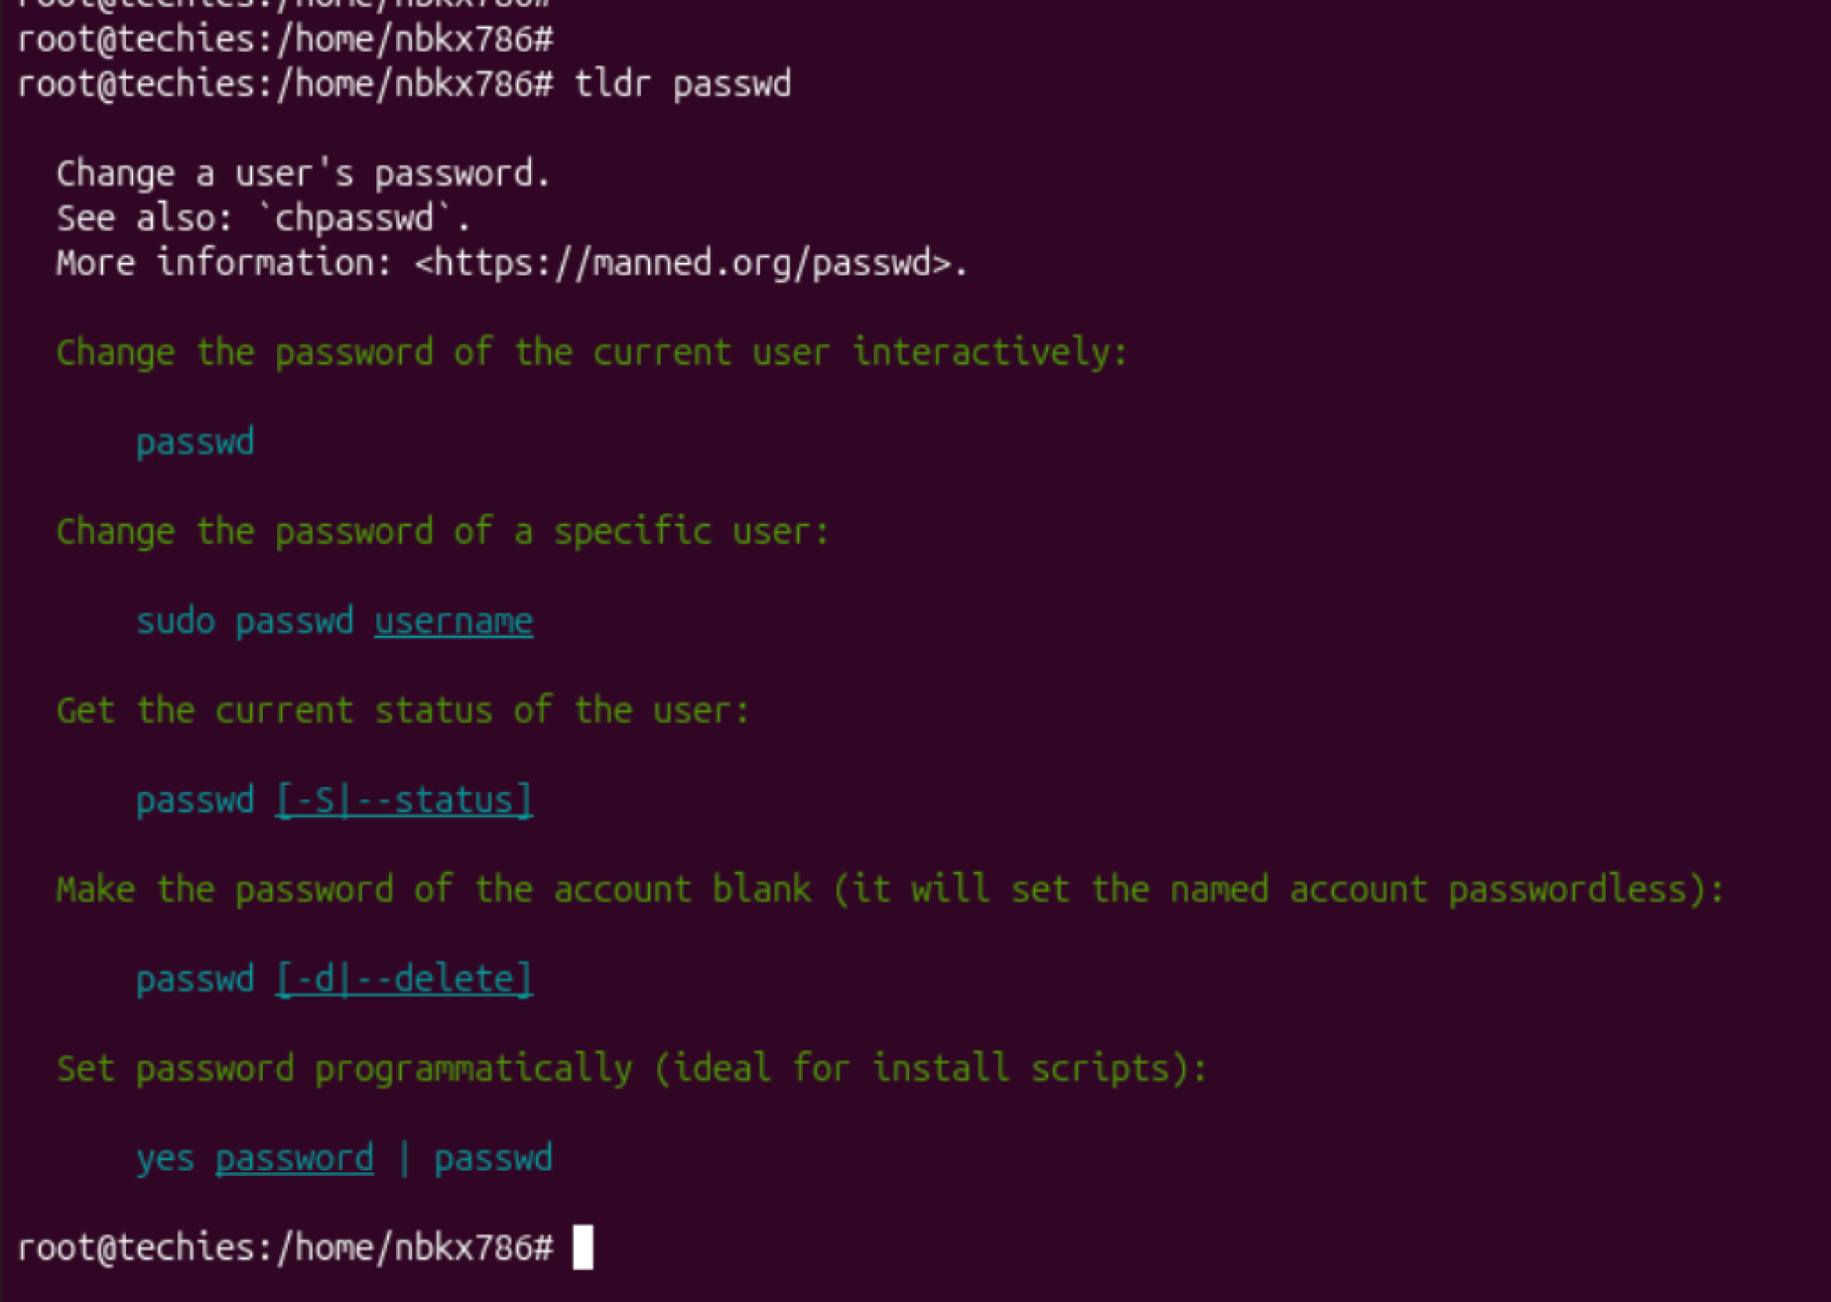
Essential File Management Tools Commands

Command: ls
- Example: ls /home/user/Documents
- Description: Lists files and directories within a specified path. This command is used to view the contents of directories.
Command: cp
- Example: cp source.txt destination.txt
- Description: Copies files from one location to another. This command is used to make duplicates of files.
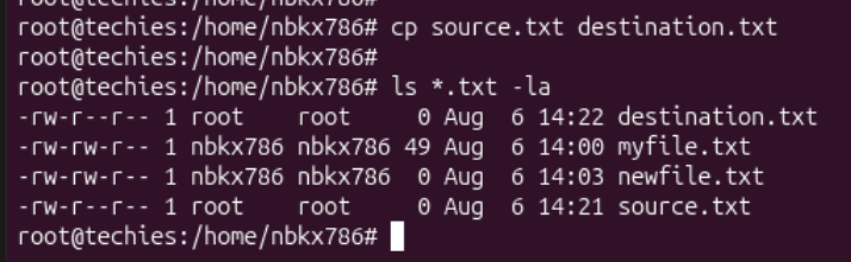
Command: mkdir
- Example: mkdir new_directory
- Description: Creates a new directory. This command is used when you need to make a new folder.
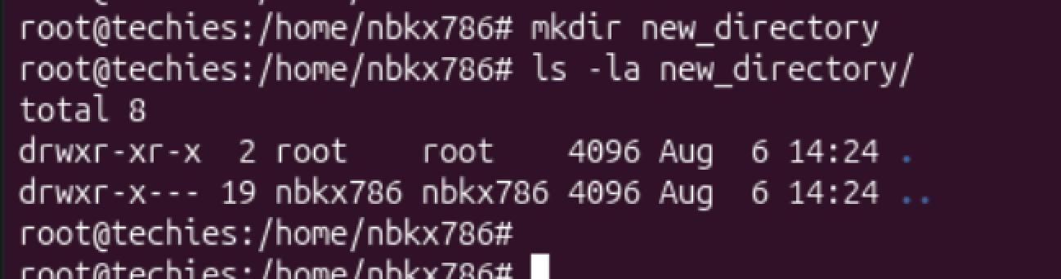
Command: rmdir
- Example: rmdir empty_directory
- Description: Removes a directory, but only if it's empty. This command is used for deleting empty folders.
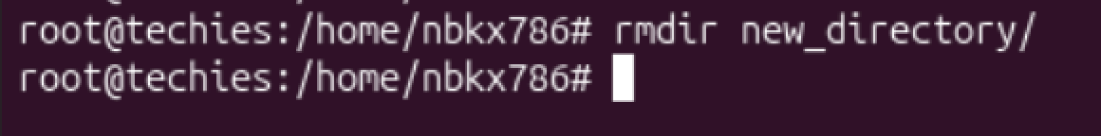
Command: mv
- Example: mv oldname.txt newname.txt
- Description: Moves or renames files and directories. This command can change the location or the name of a file.
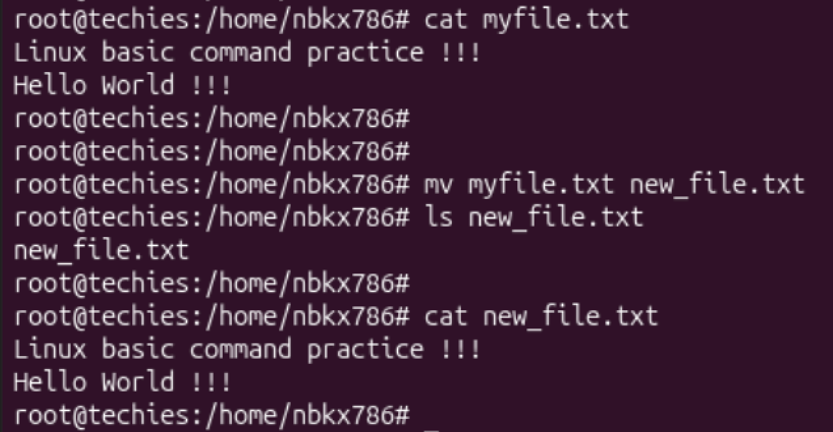
Command: rm
- Example: rm filename.txt
- Description: Removes files or directories. This command deletes files or directories.
- Note: When combined with options -r (recursive) and -f (force), as in rm -rf directory_name, it becomes a powerful command that can delete directories and their contents without asking for confirmation.
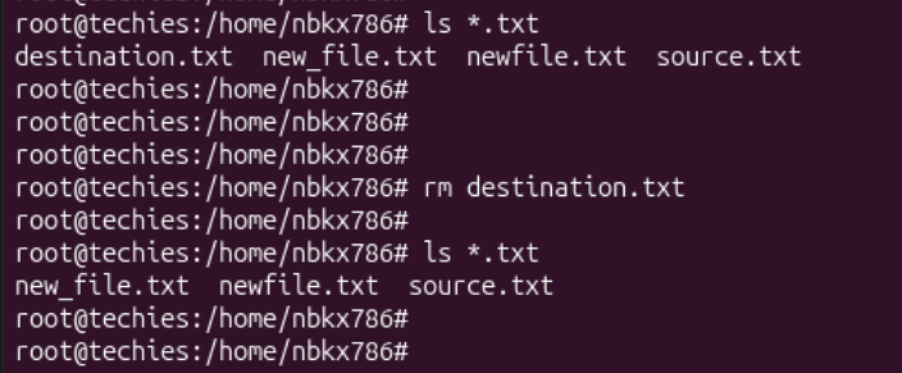
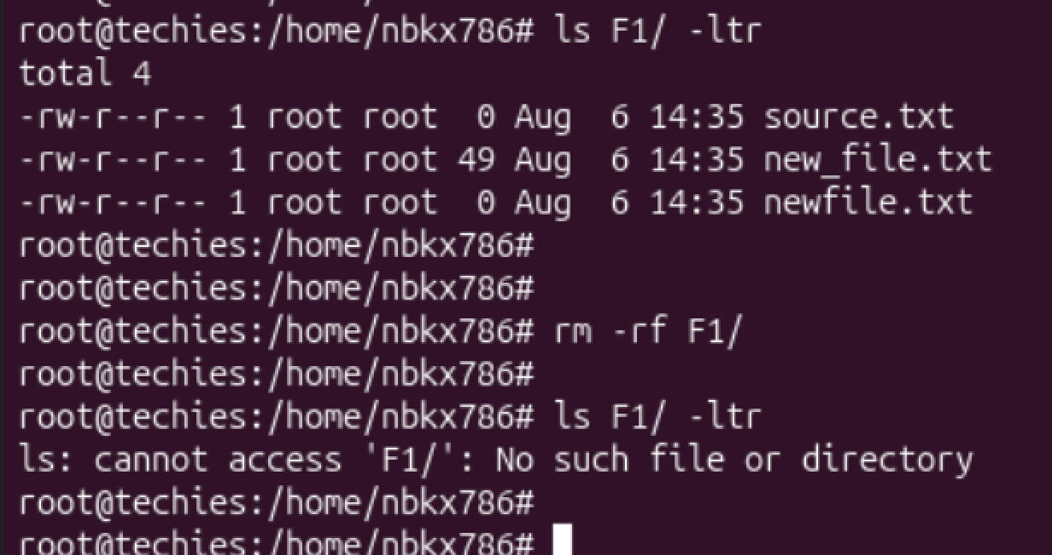
Advanced File Management Tools Commands

ln: Used for creating hard and symbolic links.
  - Example: ln -s source_file symbolic_linkcreates a symbolic link to source_file.
  - Description: Links a file or directory to another location.
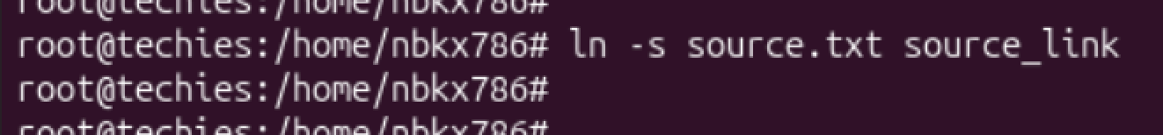
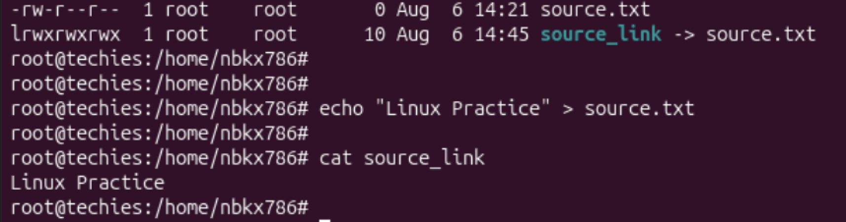
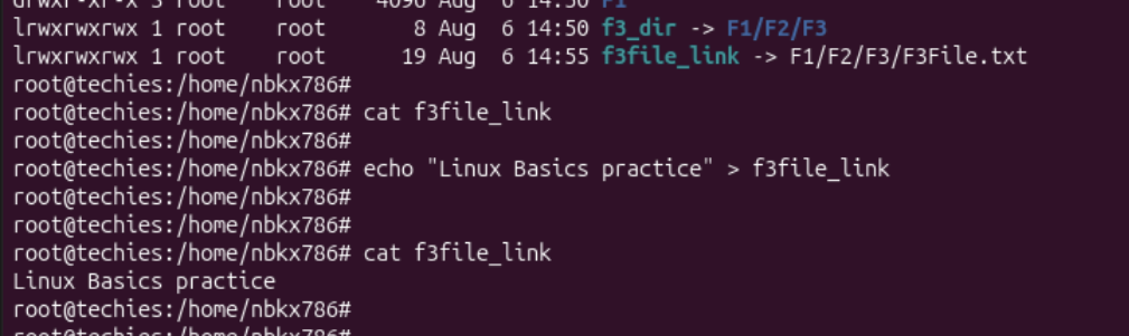
find: A utility to find files based on various properties.
  - Example: find /home -name "*.txt"searches for text files in the /home directory.
  - Description: Searches for files and directories in a given path.
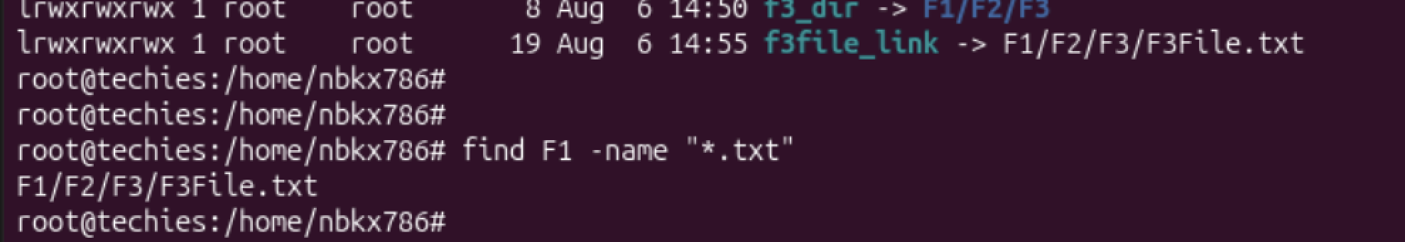
locate: Used for quickly searching the database of system's contents.
  - Example: locate filename finds the location of filename.
  - Description: Fast file searching, requires running updatedb for an updated database.
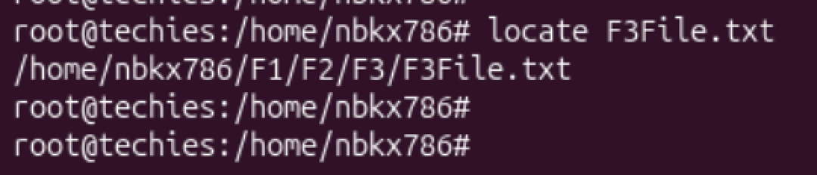
which: Finds the location of executables in the PATH.
  - Example: which python shows the path of the Python executable.
  - Description: Useful for finding executable files in system's PATH.
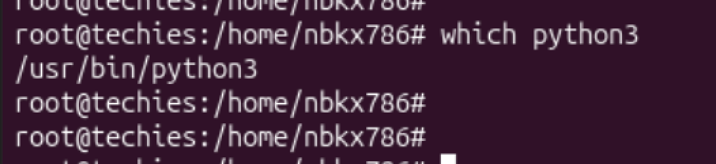
tar: Archives multiple files into a single file.
  - Example: tar -cvf archive.tar /foldercreates an archive of a folder.
  - Description: Combines multiple files into a tarball.
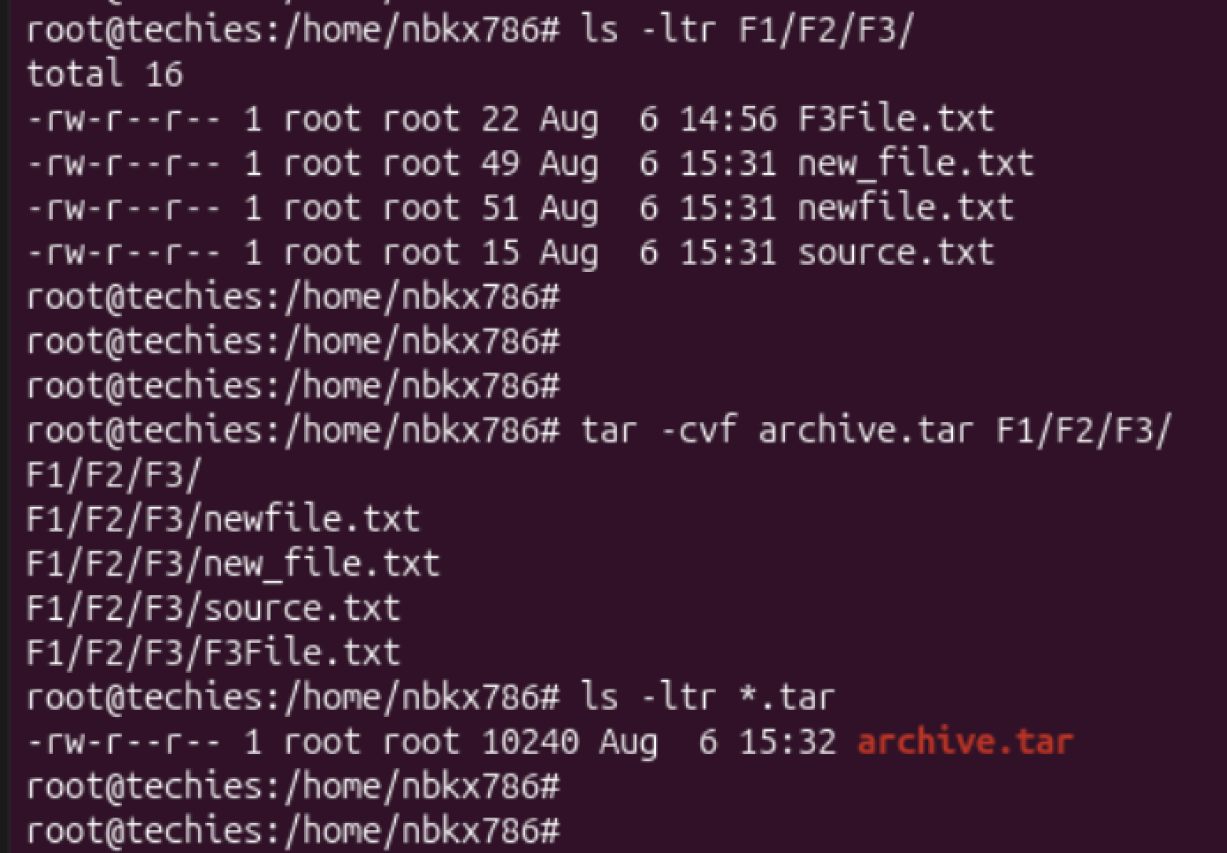
gzip: Compresses files.
  - Example: gzip file.txt compresses file.txt.
  - Description: Reduces the size of files using compression.
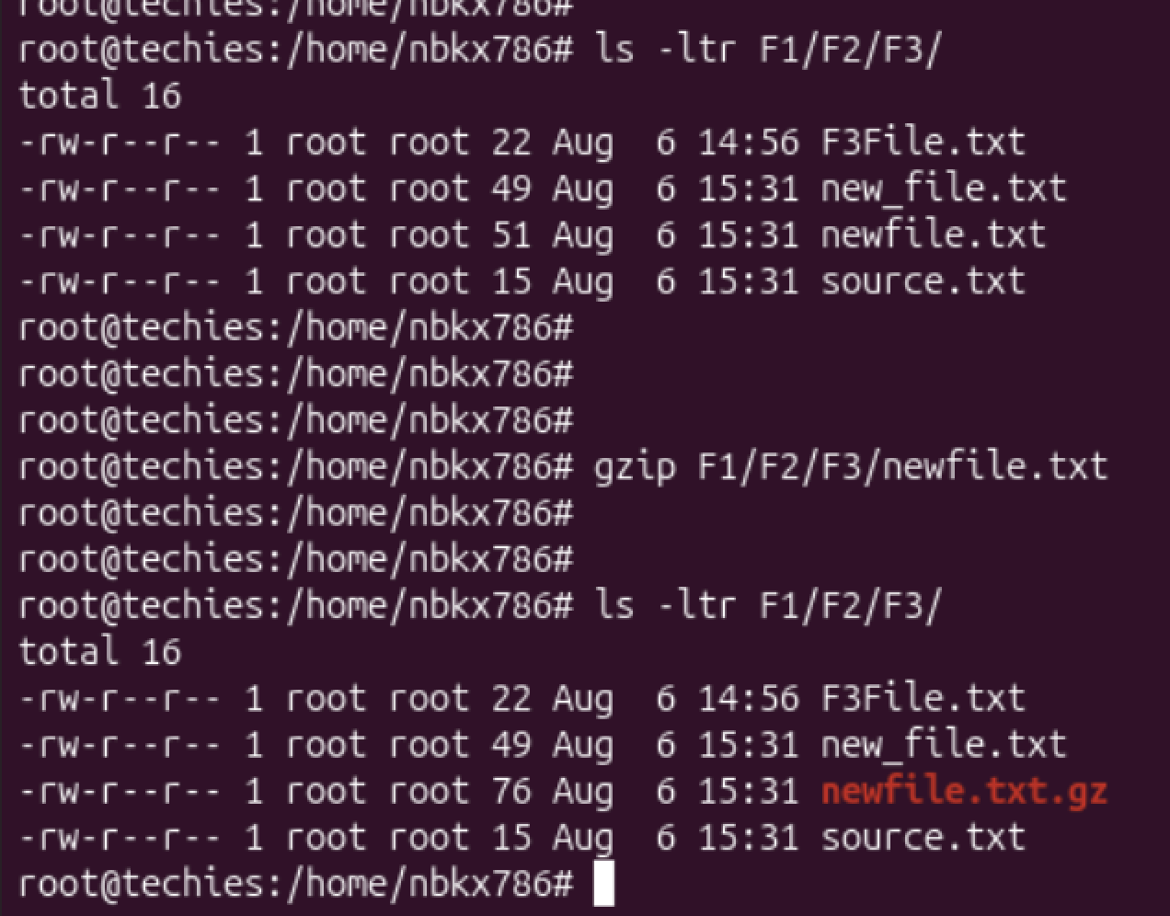
bzip2: A file compression utility.
  - Example: bzip2 file.txt compresses file.txt.
  - Description: Offers better compression ratios than gzip at the cost of speed.
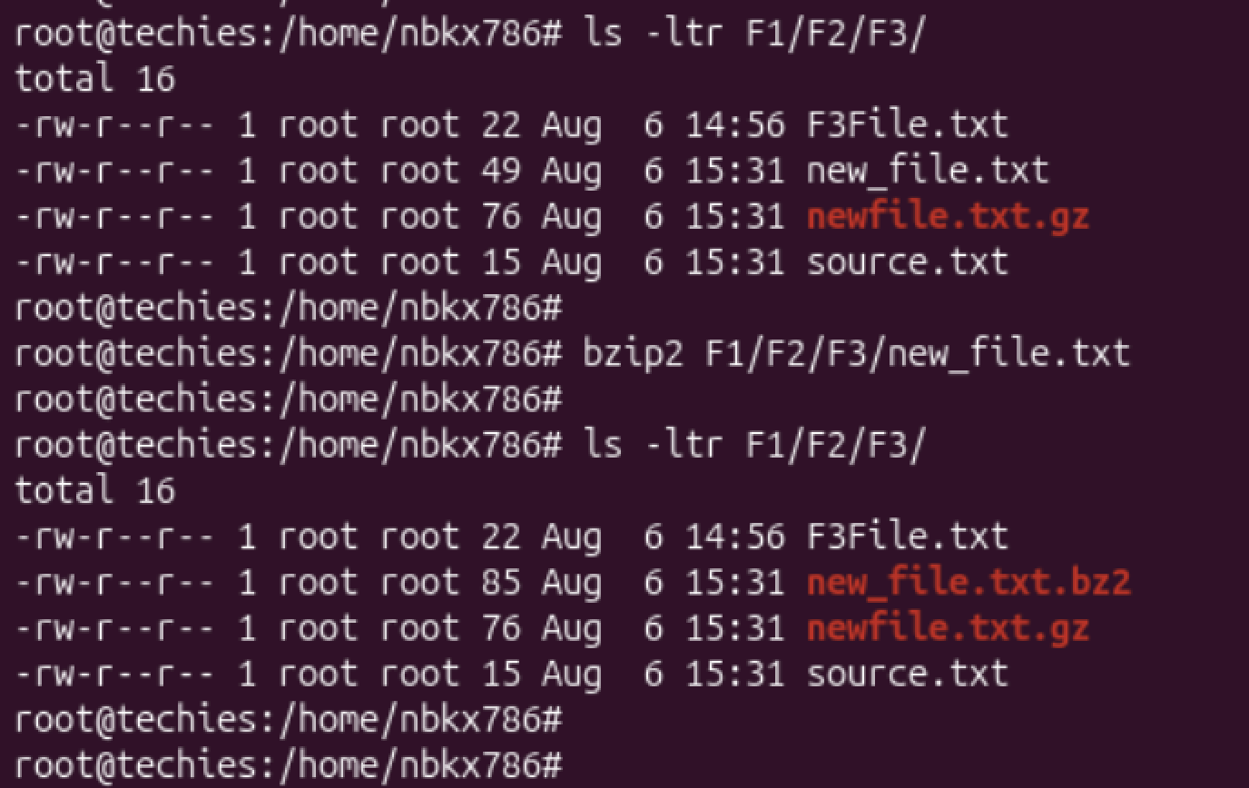
xz: High compression utility.
  - Example: xz file.txt compresses file.txt.
  - Description: Provides the best compression ratio.
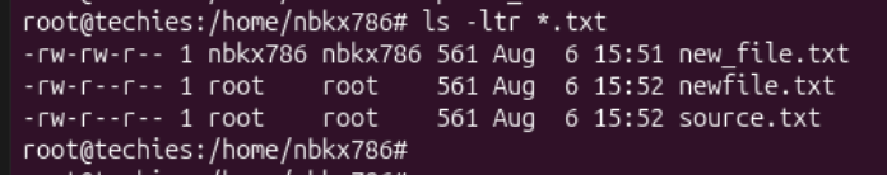
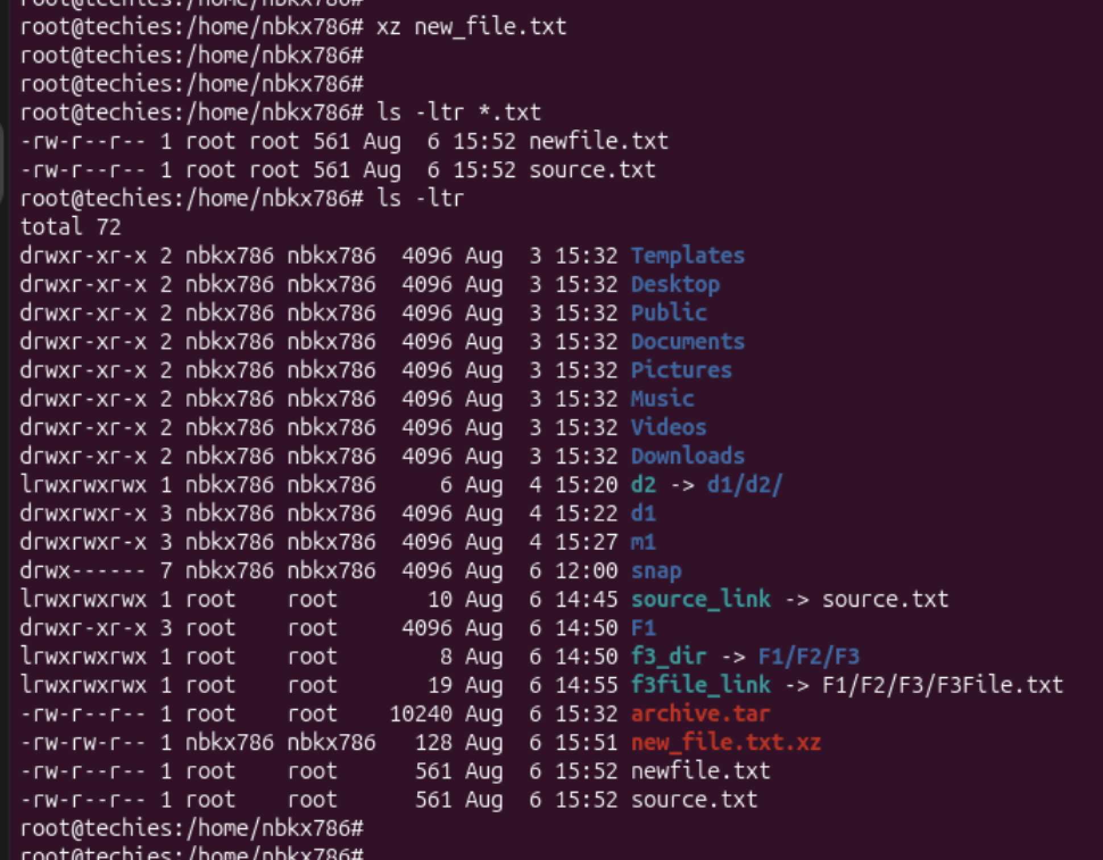
zip: Used for packaging and compressing (archiving) files.
  - Example: zip archive.zip file1 file2 creates an archive with file1 and file2.
  - Description: Commonly used for creating .zip files.
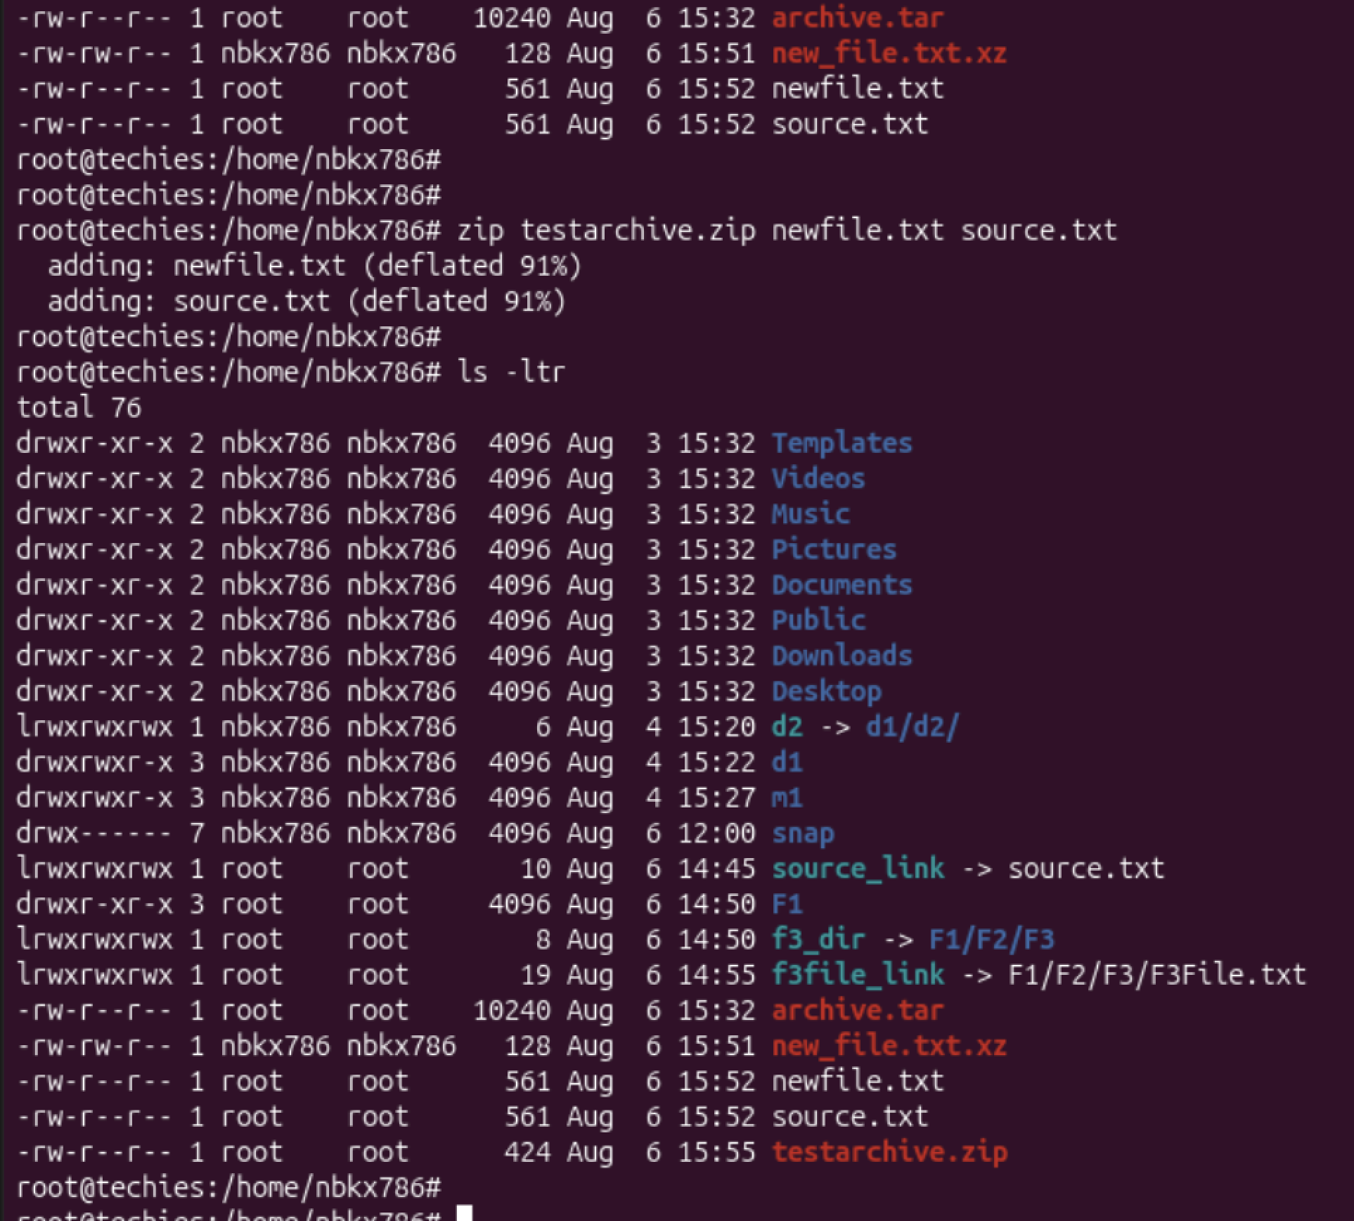
file: Determines the type of a file.
  - Example: file image.jpg displays the type of image.jpg.
  - Description: Useful for identifying file formats.
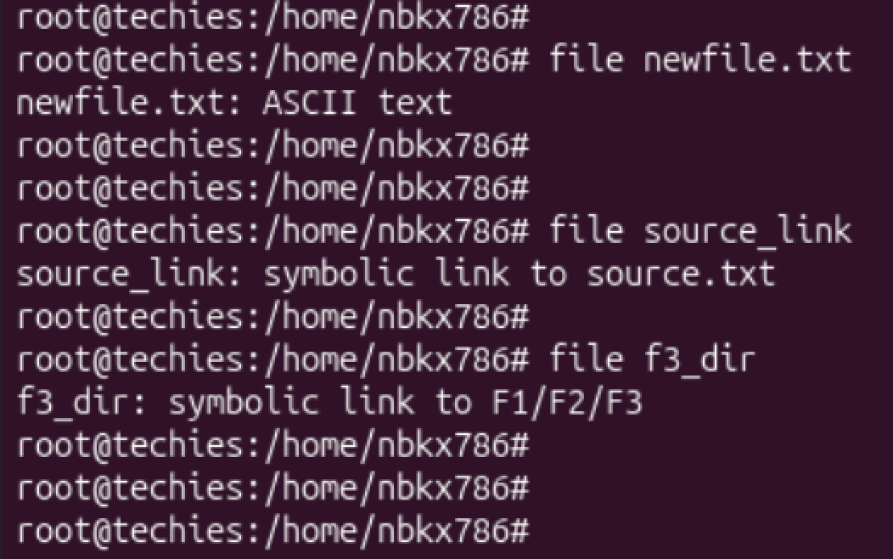
mount: Attaches a filesystem to a specified directory.
  - Example: mount /dev/sdb1 /mnt mounts the device sdb1 to /mnt.
  - Description: Used to access filesystems on different storage devices.

df: Displays disk space usage of all mounted filesystems.
  - Example: df -h shows disk space in human-readable format.
  - Description: Useful for monitoring disk space usage.
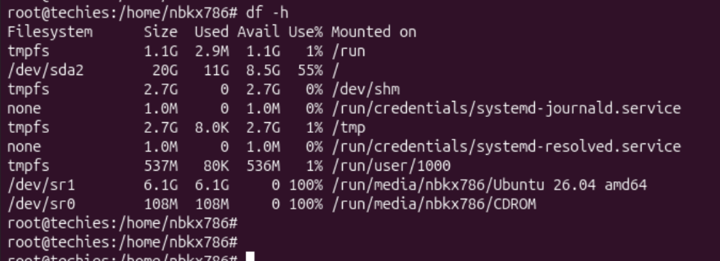
findmnt: Lists all mounted filesystems.
  - Example: findmnt -t ext4 lists all ext4 type mounts.
  - Description: Displays a tree-like structure of mounts.
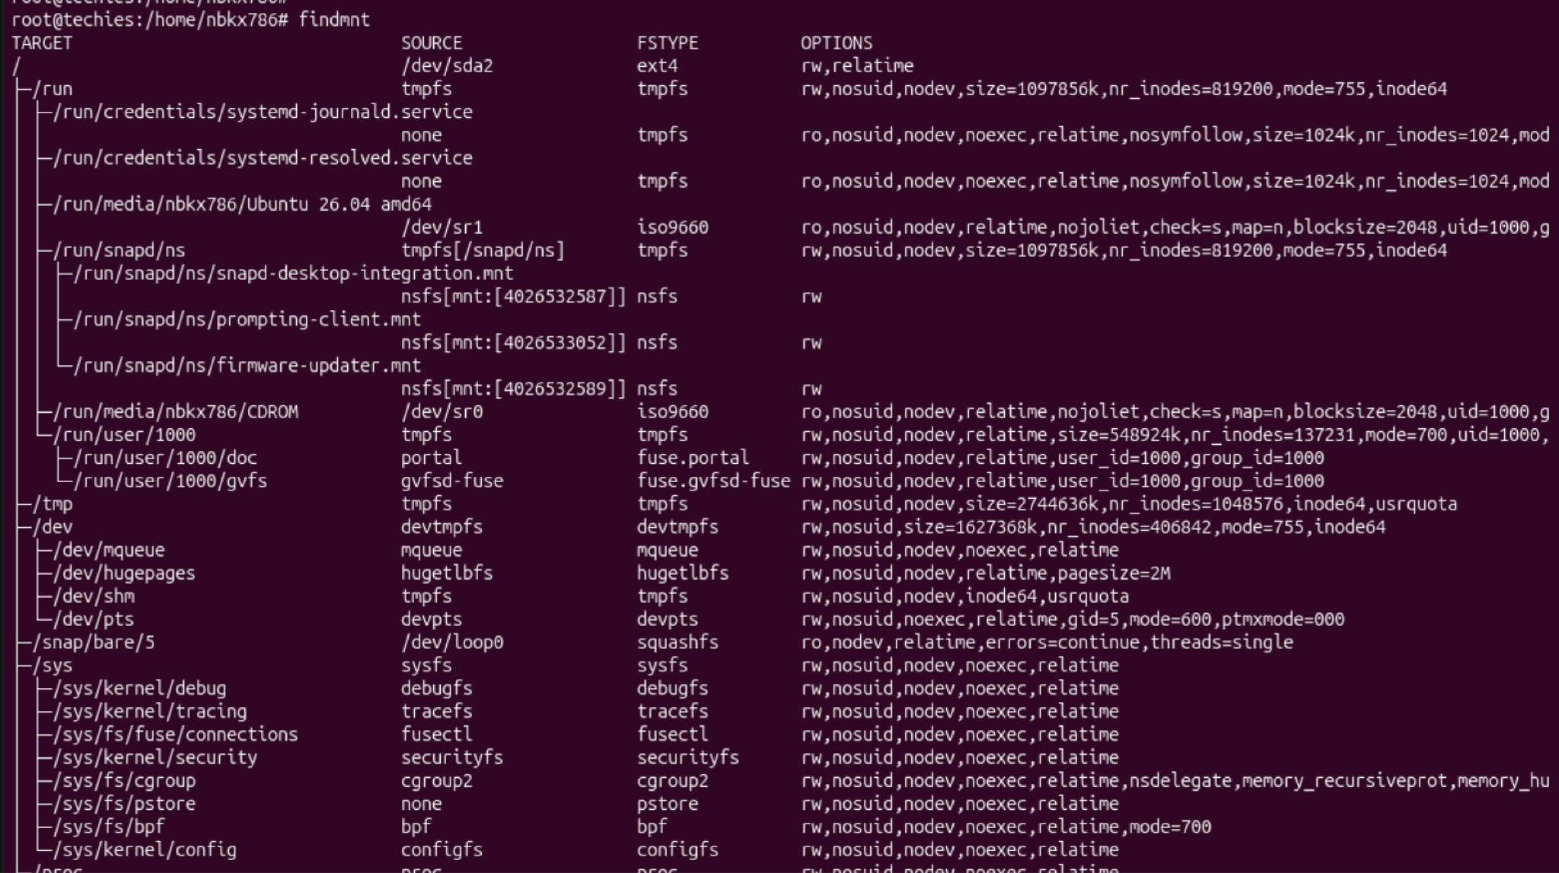
lsblk: Lists information about block devices.
  - Example: lsblk lists all block devices.
  - Description: Useful for identifying storage devices and their partitions.
